AVIATION DATABASE SQL ANALYSIS PROJECT

1. PROJECT OVERVIEW
- This project focuses on analysing an aviation database using SQL.
- The database contains information about:
  - Airlines
  - Airports
  - Flights
  - Passenger bookings
- SQL is used to retrieve, filter, organize, summarize, and analyse the aviation data.
- The project demonstrates how SQL can be applied to a real-world business scenario.
- The analysis focuses on:
  - Airline performance
  - Passenger booking patterns
  - Travel class preferences
  - Ticket pricing
  - Revenue generation
  - Airport demand
  - Route performance
- The final analysis converts the SQL results into meaningful business insights that can support data-driven decision-making.
2. PROJECT OBJECTIVE
- Main Objective
- The main objective of this project is to use SQL to analyse aviation data and identify business insights related to airline performance, passenger demand, revenue, pricing, airports, routes, and travel classes.
- Specific Objectives
- To identify airlines generating the highest revenue.
- To compare booking volumes across airlines.
- To analyse passenger preferences across different travel classes.
- To compare revenue generated by different travel classes.
- To analyse average, minimum, and maximum ticket prices.
- To identify airports with higher passenger demand.
- To analyse route-wise bookings and revenue.
- To identify high-performing routes.
- To identify airlines with strong Business Class performance.
- To identify airlines and routes crossing specific revenue thresholds.
- To compare pricing patterns among airlines and routes.
- To understand how SQL can support data-driven business decisions in the aviation industry.
3.DATABASE TABLES
- The aviation database consists of the following main tables:
3.1 Airlines Table
- Stores information about different airlines.
- Main information includes:
  - Airline ID
  - Airline Name
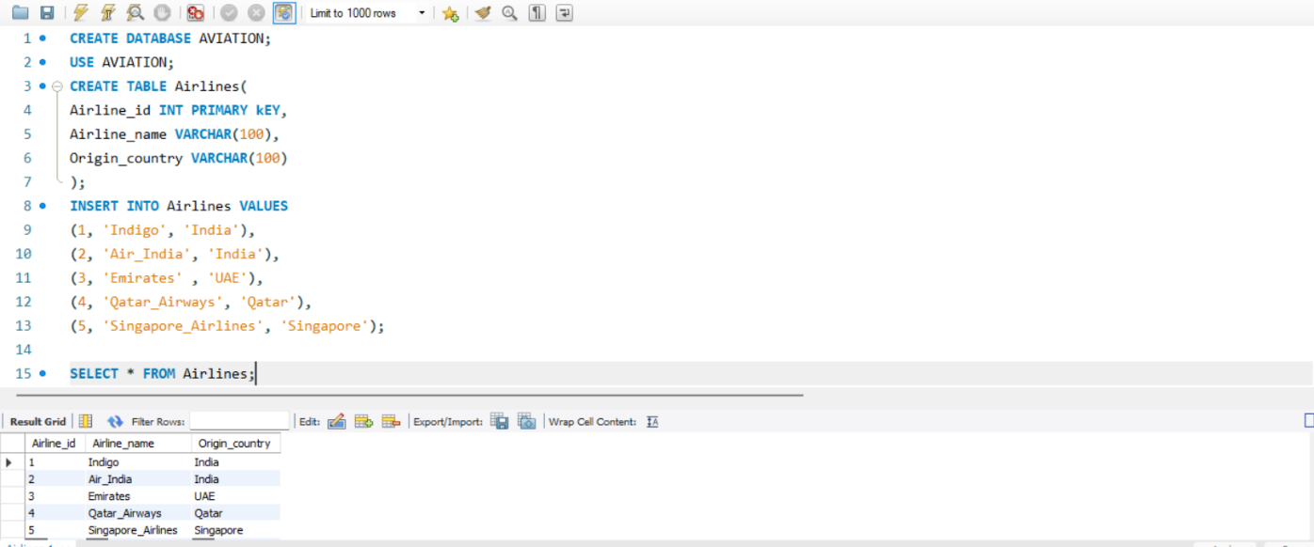
  - Country

3.2 Airports Table
- Stores information about different airports.
- Main information includes:
  - Airport ID
  - Airport Code
  - Airport Name
  - City
  - Country
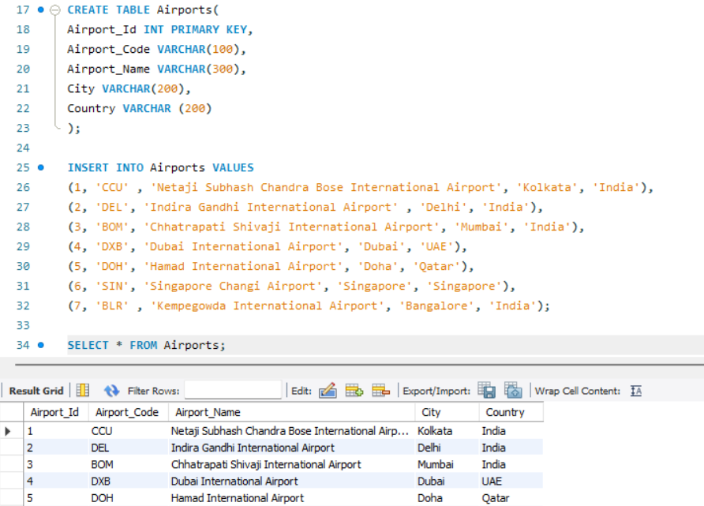

3.3 Flights Table
- Stores information about scheduled flights.
- Main information includes:
  - Flight ID
  - Airline ID
  - Flight Number
  - Origin Airport
  - Destination Airport
  - Departure Date
  - Departure Time
  - Origin Airport Code
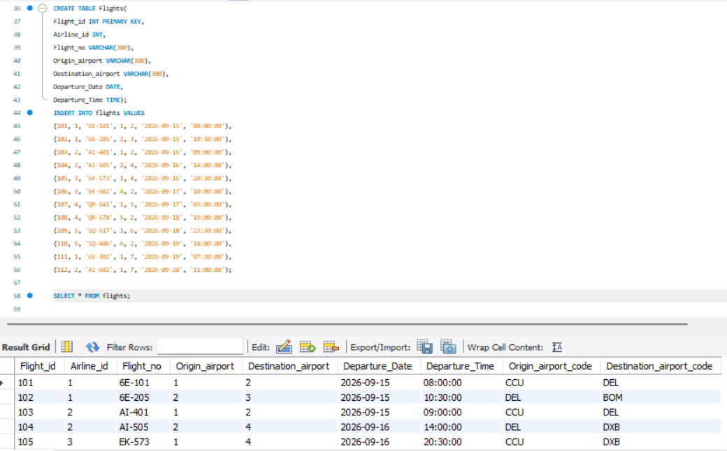
  - Destination Airport Code

3.4 Bookings Table
- Stores information about passenger bookings.
- Main information includes:
  - Booking ID
  - Flight ID
  - Passenger Name
  - Travel Class
  - Ticket Price
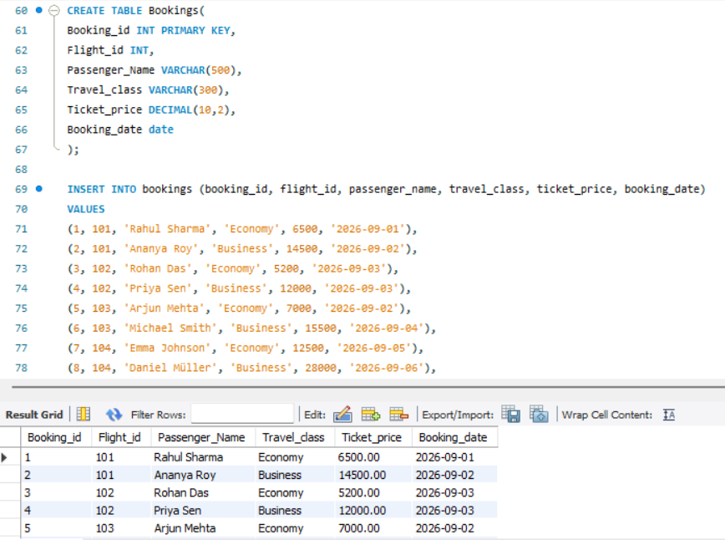
  - Booking Date

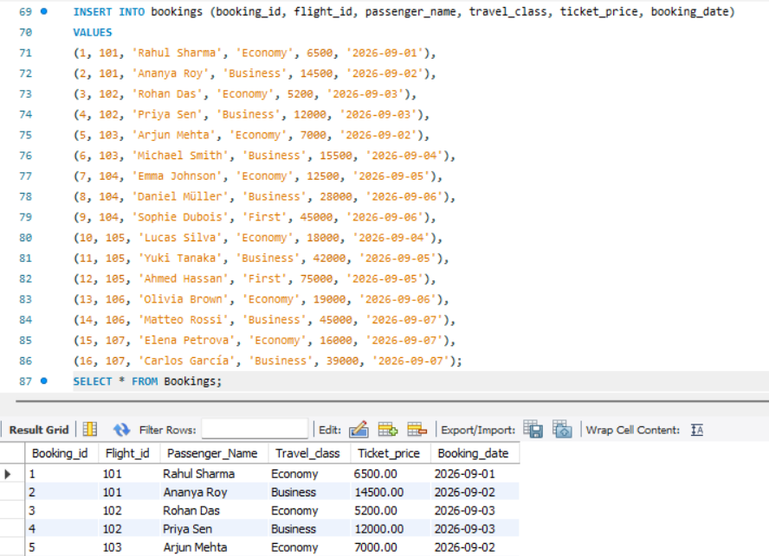

4.1 AIRLINE PERFORMANCE ANALYSIS
Question 1: Which airline generates the highest total revenue?
- Purpose
- To identify the airline with the strongest revenue performance.
- This can help evaluate airline-level financial performance.
- Query
SELECT Airlines.Airline_name,SUM(Bookings.Ticket_price) FROM Bookings RIGHT JOIN Flights ON Bookings.Flight_id = Flights.Flight_id RIGHT JOIN Airlines ON Flights.Airline_id = Airlines.Airline_id GROUP BY Airlines.Airline_name ORDER BY SUM(Bookings.Ticket_price) DESC LIMIT 1;
- Output
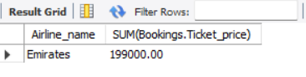
Question 2: Which airline receives the highest number of bookings?
- Purpose.
- To identify airlines with higher passenger booking activity.
- This can help understand relative customer demand.
- Query
SELECT Airlines.Airline_name, COUNT(Bookings.Booking_id) AS Total_no_of_bookings FROM Bookings LEFT JOIN Flights ON Bookings.Flight_id = Flights.Flight_id RIGHT JOIN Airlines ON Flights.Airline_id = Airlines.Airline_id GROUP BY Airlines.Airline_name ORDER BY Total_no_of_bookings DESC LIMIT 2;
- Output
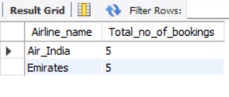
Question 3: What is the average ticket price for each airline?
- Purpose
- To compare the average ticket prices of different airlines.
- To understand differences in airline pricing levels.
- This can help identify airlines positioned at relatively higher or lower fare levels.
- Query
SELECT Airlines.Airline_name , AVG(Bookings.Ticket_price) AS Average_ticket_price FROM Bookings RIGHT JOIN Flights ON Bookings.Flight_id = Flights.Flight_id RIGHT JOIN Airlines ON Airlines.Airline_id GROUP BY Airlines.Airline_name ORDER BY Average_ticket_price DESC;
- Output
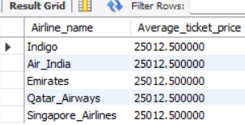
Question 4: Which airline offers the cheapest ticket?
- Purpose
- To identify the lowest ticket price associated with each airline.
- To compare the minimum fares offered by different airlines.
- This can help understand the lower end of airline pricing.
- Query
SELECT Airlines.Airline_name , MIN(Bookings.Ticket_price) AS Ticket_price FROM Bookings RIGHT JOIN Flights ON BookingS.Flight_id = Flights.Flight_id RIGHT JOIN Airlines ON Airlines.Airline_id GROUP BY Airlines.Airline_name ORDER BY Ticket_price ASC LIMIT 1;
- Output
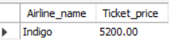
4.2 TRAVEL CLASS ANALYSIS
Question 5: Find the number of bookings in each travel class?
- Purpose
- To compare passenger bookings across Economy, Business, and First Class.
- To identify the most frequently selected travel class.
- This can help understand passenger preferences.
- Query
SELECT Travel_class ,COUNT(Booking_id) FROM Bookings GROUP BY Travel_class;
- Output
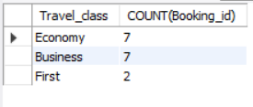
Question 6: How much revenue is generated by each travel class?
- Purpose
- To compare revenue generated by Economy, Business, and First Class.
- To identify which travel class contributes the most revenue.
- This can help evaluate the financial importance of different passenger segments.
- Query
SELECT Travel_class, SUM(Ticket_price) FROM Bookings GROUP BY Travel_class;
- Output
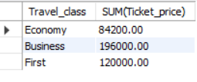
Question 7: What is the average ticket price for each travel class?
- Purpose
- To compare average ticket prices across different travel classes.
- To understand the pricing difference between Economy, Business, and First Class.
- This can help understand the value associated with each class.
- Query
SELECT Travel_class, AVG(Ticket_price) FROM Bookings GROUP BY Travel_class;
- Output
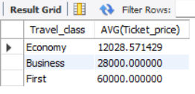
Question 8: Which airline has the most Business Class bookings?
- Purpose
- To identify the airline with the highest Business Class demand.
- To understand which airline attracts more premium-class passengers.
- This can help evaluate Business Class market performance.
- Query
SELECT Airlines.Airline_name, Bookings.Travel_class, COUNT(Bookings.Booking_id) FROM Bookings RIGHT JOIN Flights ON Bookings.Flight_id = Flights.Flight_id RIGHT JOIN Airlines ON Flights.Airline_id = Airlines.Airline_id WHERE Bookings.Travel_class = 'Business' GROUP BY Airlines.Airline_name, Bookings.Travel_class ORDER BY COUNT(Bookings.Booking_id) DESC ;
- Output
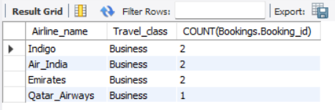
Question 9: Which airline generates the most Business Class revenue?
- Purpose
- To identify the airline generating the highest revenue from Business Class bookings.
- To evaluate the financial performance of the premium passenger segment.
- This can help identify airlines with stronger Business Class revenue potential.
- Query
SELECT Airlines.Airline_name , Bookings.Travel_class, SUM(Bookings.Ticket_price) FROM Bookings RIGHT JOIN Flights ON Bookings.Flight_id = Flights.Flight_id RIGHT JOIN Airlines ON Flights.Airline_id = Airlines.Airline_id WHERE Travel_class = 'Business' GROUP BY Airlines.Airline_name , Bookings.Travel_class ORDER BY SUM(Bookings.Ticket_price) DESC LIMIT 1;
- Output
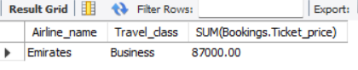
4.3 AIRPORT & ROUTE ANALYSIS
Question 10: Which origin airport has the highest number of bookings?
- Purpose
- To identify the origin airport with the highest passenger booking volume.
- To understand airport-level passenger demand.
- This can help in understanding which airports have greater booking activity.
- Query
SELECT Airports.Airport_Name, COUNT(Bookings.Booking_id) AS Number_of_Bookings FROM Flights LEFT JOIN Bookings ON Flights.Flight_id = Bookings.Flight_id JOIN Airports ON Flights.Origin_airport_code = Airports.Airport_Code GROUP BY Airports.Airport_Name ORDER BY Number_of_Bookings DESC LIMIT 1;
- Output

Question 11: Which route receives the highest number of bookings?
- Purpose
- To identify routes with higher booking activity.
- This can help identify routes with stronger passenger demand.
- Query
SELECT Flights.Origin_airport_code , Flights.Destination_airport_code, COUNT(Bookings.Booking_id) AS Total_number_of_bookings FROM Bookings RIGHT JOIN Flights ON Bookings.Flight_id = Flights.Flight_id GROUP BY Flights.Origin_airport_code , Flights.Destination_airport_code ORDER BY Total_number_of_bookings DESC LIMIT 1 ;
- Output

Question 12: Which route generates the highest total revenue?
- Purpose
- To compare revenue generated by different routes.
- To identify the highest-revenue route.
- This can help evaluate route-level financial performance.
- Query
SELECT Flights.Origin_airport_code , Flights.Destination_airport_code, SUM(Bookings.Ticket_price) AS Total_revenue FROM Bookings RIGHT JOIN Flights ON Bookings.Flight_id = Flights.Flight_id GROUP BY Flights.Origin_airport_code , Flights.Destination_airport_code ORDER BY Total_revenue DESC LIMIT 1 ;
- Output
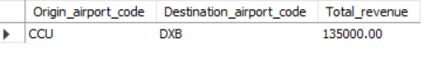
Question 13: What is the average ticket price for each route?
- Purpose
- To compare average ticket prices across different routes.
- To identify routes with relatively higher or lower fare levels.
- This can help understand route-wise pricing patterns
- Query
SELECT Flights.Origin_airport_code , Flights.Destination_airport_code, AVG(Bookings.Ticket_price) AS Average_revenue FROM Bookings RIGHT JOIN Flights ON Bookings.Flight_id = Flights.Flight_id GROUP BY Flights.Origin_airport_code , Flights.Destination_airport_code ORDER BY Average_revenue DESC ;
- Output
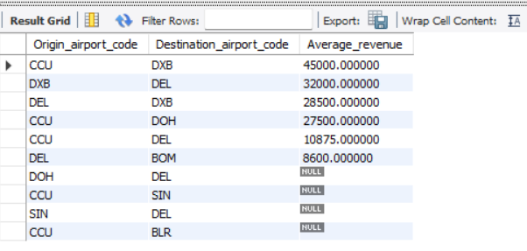
Question 14: Which routes have total revenue greater than ₹50,000?
- Purpose
- To identify routes that cross the specified revenue threshold.
- To identify routes making a significant contribution to total revenue.
- This can help highlight potentially important routes for revenue management.
- Query
SELECT Flights.Origin_airport_code , Flights.Destination_airport_code, SUM(Bookings.Ticket_price) AS Total_revenue FROM Bookings RIGHT JOIN Flights ON Bookings.Flight_id = Flights.Flight_id GROUP BY Flights.Origin_airport_code , Flights.Destination_airport_code HAVING Total_revenue > 50000 ORDER BY Total_revenue DESC;
- Output
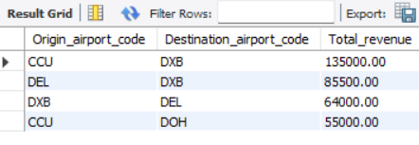
4.4 PRICING ANALYSIS
Question 15: What is the cheapest and most expensive ticket?
- Purpose
- To identify the minimum and the maximum ticket price in the dataset.
- Query
- For cheapest
SELECT Airlines.Airline_name , MIN(Bookings.Ticket_price) AS Ticket_price FROM Bookings RIGHT JOIN Flights ON BookingS.Flight_id = Flights.Flight_id RIGHT JOIN Airlines ON Flights.Airline_id = Airlines.Airline_id GROUP BY Airlines.Airline_name ORDER BY Ticket_price ASC LIMIT 2;
- For expensive
SELECT Airlines.Airline_name , MAX(Bookings.Ticket_price) AS Ticket_price FROM Bookings RIGHT JOIN Flights ON BookingS.Flight_id = Flights.Flight_id RIGHT JOIN Airlines ON Flights.Airline_id = Airlines.Airline_id GROUP BY Airlines.Airline_name ORDER BY Ticket_price DESC LIMIT 1;
- Output
Cheapest ticket
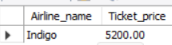
Expensive ticket
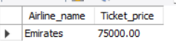
Question 16: What is the average ticket price?
- Purpose
- To identify the average ticket price in the dataset
- Query
SELECT AVG(Ticket_price) FROM Bookings;
- Output
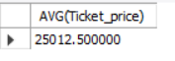
Question 17: Compare pricing between average Travel Classes?
- Purpose
- To compare the average ticket prices of different travel classes.
- To understand the pricing difference between Economy, Business, and First Class.
- To identify which travel class has a relatively higher average ticket price.
- Query
SELECT Travel_class, AVG(Ticket_price) FROM Bookings GROUP BY Travel_class;
- Output
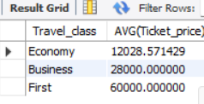
4.5. REVENUE ANALYSIS
Question 18: Find the total revenue airline and route wise
- Purpose
- To calculate the total revenue generated by each airline and each route.
- To compare revenue performance across airlines and routes.
- To identify the airlines and routes that contribute the most to overall revenue.
- To support better decisions related to pricing, route management, and resource allocation.
- Query
SELECT Airlines.Airline_name, Flights.Origin_airport_code, Flights.Destination_airport_code, SUM(Bookings.Ticket_price) AS Total_Revenue FROM Flights LEFT JOIN Bookings ON Flights.Flight_id = Bookings.Flight_id JOIN Airlines ON Flights.Airline_id = Airlines.Airline_id GROUP BY Airlines.Airline_name, Flights.Origin_airport_code, Flights.Destination_airport_code;
- Output
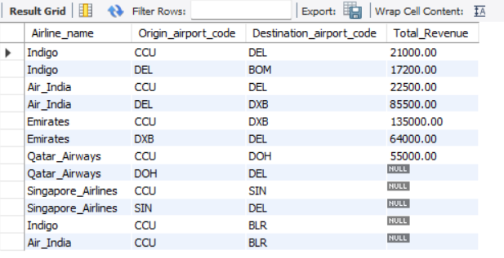

5. FINAL BUSINESS FINDINGS
- Airline Performance
- Emirates generates the highest total revenue among the airlines.
- Emirates and Air India receive the highest number of bookings.
- The average ticket price is 25012.50
- IndiGo offers the cheapest ticket in the dataset.
- Travel Class Analysis
- Economy and Business Class have the highest number of bookings.
- Business Class generates the highest total revenue.
- First Class has the highest average ticket price.
- IndiGo and Air India and Emirates have the highest number of Business Class bookings.
- Emirates generates the highest Business Class revenue.
- Airport & Route Analysis
- CCU (Kolkata) has the highest number of bookings among the origin airports.
- CCU–DEL (Kolkata–Delhi) receives the highest number of bookings.
- CCU–DXB (Kolkata–Dubai) generates the highest total route revenue.
- Pricing Analysis
- The cheapest ticket in the dataset is ₹5,200 which is offered by Indigo
- The most expensive ticket is ₹75,000 which is offered by Emirates
- First Class has a significantly higher average ticket price than Business and Economy Class.
- Economy Class has the lowest average ticket price among the three travel classes.
- There is a clear difference in ticket pricing across travel classes.
- Revenue Analysis
- Emirates is the strongest airline in terms of total revenue.
- CCU–DXB is the highest-revenue route.
- Business Class makes an important contribution to overall revenue despite having fewer high-value tickets than First Class.
6. SQL Concepts and Techniques Used
- SELECT – to retrieve required data.
- WHERE – to filter records based on conditions.
- ORDER BY – to sort results in ascending or descending order.
- Aggregate Functions – SUM(), AVG(), MIN(), MAX(), and COUNT().
- GROUP BY – to group data for analysis.
- HAVING – to filter grouped results based on aggregate conditions.
- INNER JOIN – to combine related data from different tables.
- LEFT JOIN – to retain all records from the left table.
- RIGHT JOIN – to retain all records from the right table.
- Multiple-table JOINs – to analyse data across airlines, flights, airports, and bookings.
- Aliases – to make table and column references easier to understand.
- LIMIT – to identify top results such as the highest or lowest value.
7. Project Conclusion
- SQL was used to analyse aviation data related to airlines, flights, bookings, routes, pricing, and revenue.
- The analysis helped identify important patterns in passenger demand and airline performance.
- The project demonstrates how SQL can support data-driven business decisions in the aviation industry.

